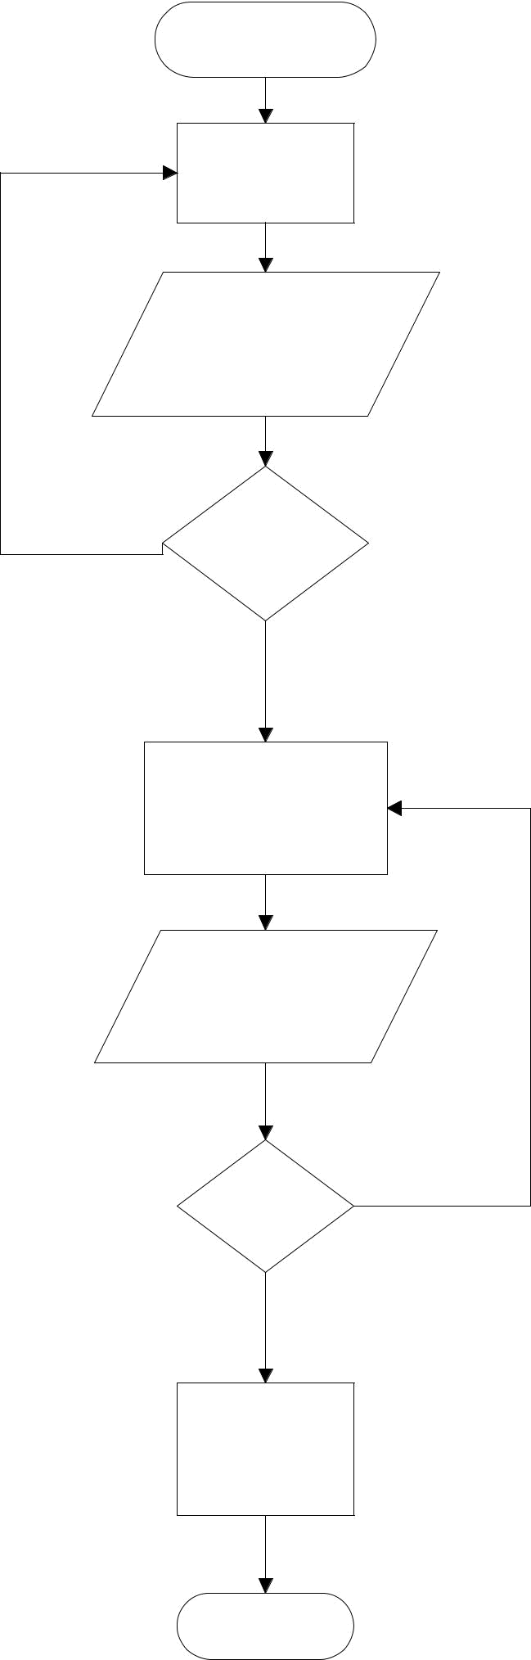
START

Request a room

from OSA

Input id number,

name of org. room
_{NO} num. reason of

reservation

If approved

proceed

YES

Students will fill up the

form from the PPO

Input num of

student, hrs of
meeting, chairs,
tables ^{NO}

If approved

proceed

YES

Print form of the

reserved room

END

WEB BASED ROOM RESERVATION SYSTEM

Introduction
- The process is reserving a room usually involves manual input and can take few more hours in our time. The current reservation system Is long and arduous process and time consuming because it is manually done.

CURRENT STATE OF TECHNOLOGY IN OSA
The rapid growth of technology has contributed a lot to the continued progress of all classification of industry. However, some sectors today seem to be left behind in adapting the use of different methods to have progress on their part. Computerization is a control system that manages processes in the industrial workplace. It reduces human errors and processing time, thus it can boost productivity and result into a high quality of product produce. This can result in a system well integrated process that can perform much faster and more accurate than the manual system.
The Web Based Room Reservation System is appropriate for the use of students for faster and convenient room reservation for their own purpose. This system provides the user to reserve room for easy access base on the given schedule of the system.

RESEARCH OBJECTIVES
The long term goal of the research is to develop an automated room reservation system for the students and its members of the available clubs and organizations in the school.

GENERAL OBJECTIVES
The study aims to develop a reservation system for OSA to help them solve the underlying problems with their manual reservation system such as consuming time and effort.

SPECIFIC OBJECTIVES
- Real time information of availability of rooms
- To provide a web site that can allow a user to search and reserve a room or cancel his/her reservation any time.
- To automate manual reservation.
- To help speed up the process in the OSA
- To reduce the amount of time to and effort consume by the students and teachers
SCOPE AND LIMITATIONS OF THE RESEARCH

This study aims and introduces the Web Based Room Reservation System for Notre Dame of Dadiangas University. The web based room reservation system is consisting of six modules, the homepage, login, fill-up form screen, room reservation information screen for the user, Administrator Information Screen for approval and the completion notification screen for the user. The system can only be use in the Office of Student Affairs and the students and professors of Notre Dame of Dadiangas University.

SIGNIFICANCE OF THE RESEARCH
Reservation System for the OSA is very significant to those who reserves and to the staff of the office who makes reservation. Instead of wasting their time and effort in moving one office to another manually, the proposed system will make a better and much easier way of reserving rooms for clubs and organizations. Less burden to those who waste their time in signing manual system.

System Functions

(Home Page)

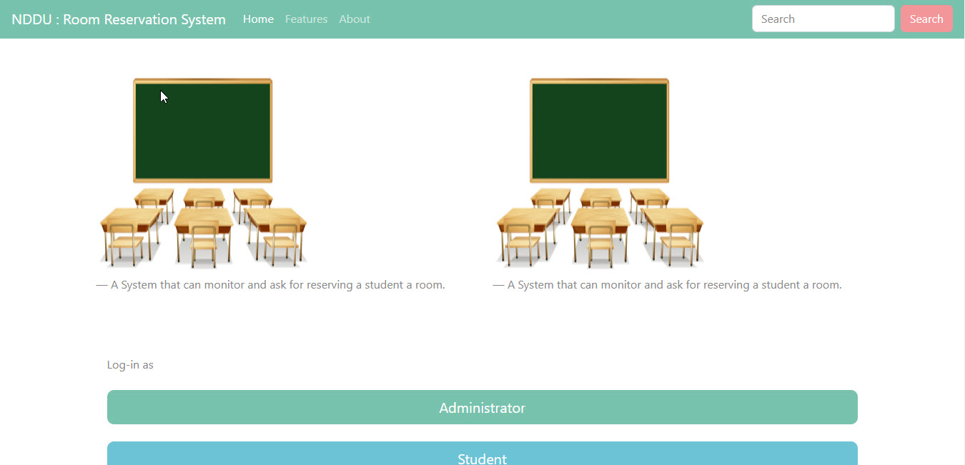

- When you open up the browser for the system. This will be the first thing you will saw. As you can see, there’s two option for the login; Administrator and Student.

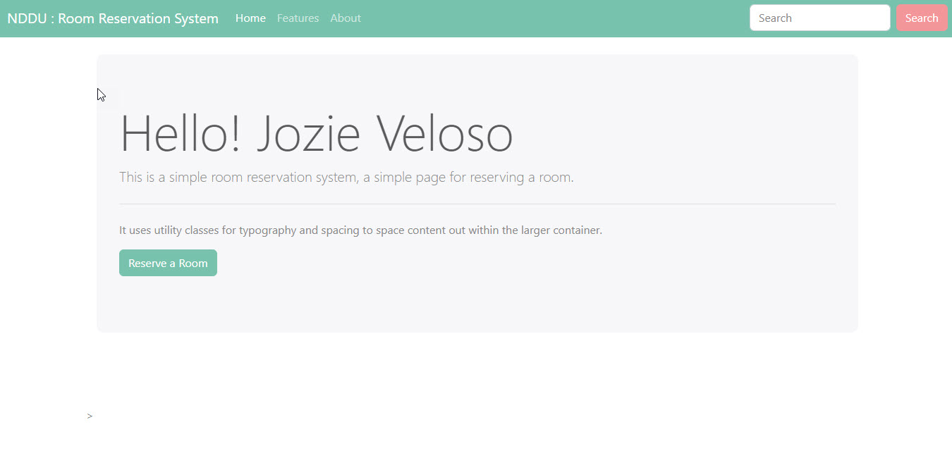

- The next thing the user will see after they login is the welcoming note from the system as indicated at the picture above. The user can now then click the “Reserve a Room” active button.

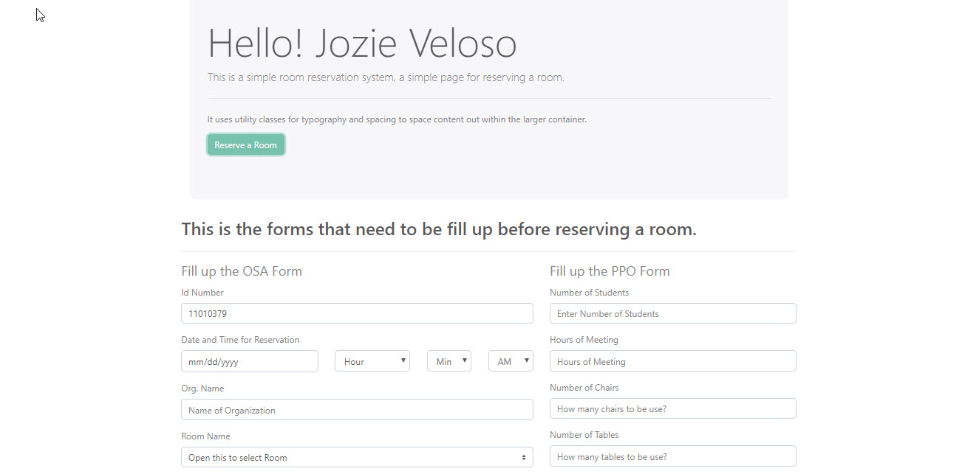

- After the user clicks the button, the system will show the user a new function below where the user is required to fill up the necessary forms before proceeding to reserve a room. (See the picture above)

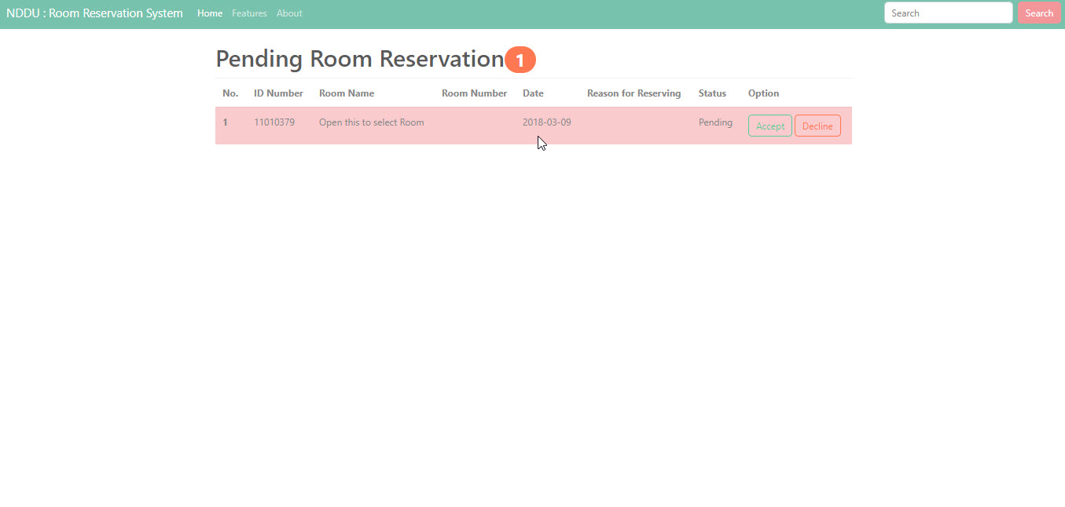

- After the user completed filling up the required information, the system will enable the user to see the information it has submitted before the user can decide to accept or decline it for further changes. If the user will click the accept button on the option, the system will forward the information to the PPO to review the whole information inputted by the user. And if the user will click the decline button, the system will bring back the user to the fill-up form function.

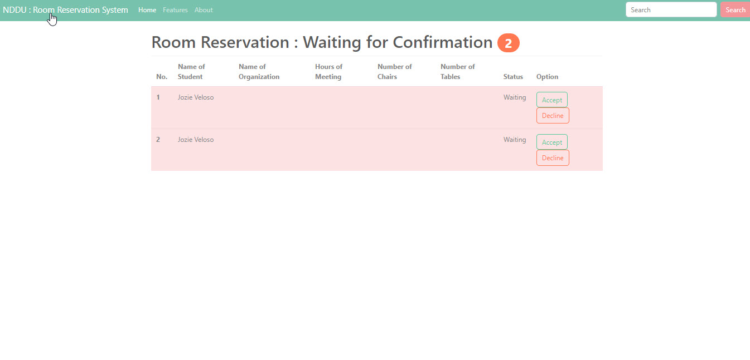

- If the user clicks the accept button, the PPO administrator can now see the information inputted by the user. The administrator can now then choose the options accept or decline.

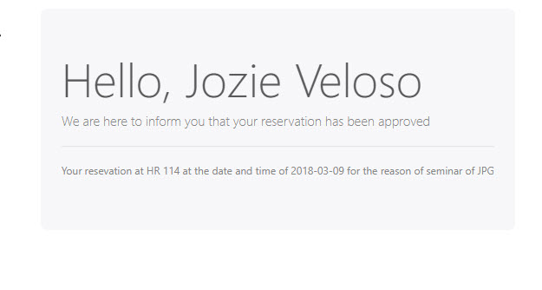
- If the administrator clicks the accept button on the options, the user will receive a notification from the system that informs the user that the reservation has been approved. (See the above picture)

